KIDS CAMP SUNDAY
AUGUST 17, 2025
Visitors: Welcome to Spirit of Life Presbyterian Church! Thank you for worshiping with us. Visitors, regular attenders and members, please complete the Connect/Prayer card and indicate if you wish to receive our weekly emails. If you don’t have a card, please pick one up from our Information Table at the back of the sanctuary. Please return completed Connect/Prayer card in offering plate or in box labeled accordingly at the back. If you have any questions, please ask at the Information Table or Pastor Rob.

Weekday Events:
· (Tuesday) COFFEE and CONVERSATION with Pastor Rob meets Tuesdays, 9:00-10:00 am. Plan to join us Tuesday and come as you are. This week we return to meeting at Spirit of Life in person, or online. It is open for you to pop in and out any time so feel free to drop in and say hello. *Note, same time and same login, recurring meeting each week. Join Zoom Meeting at https://zoom.us/j/286584190.
· MEN’S BIBLE STUDY GROUP meets Wednesdays at the church over the summer. Our Men's Bible study group will meet the 2nd & 4th Wednesday for the summer so our next meeting is Wednesday, August 27th, at 6:00 PM, at Spirit of Life.

It takes all of us to be the church. Leadership has worked diligently to organize the opportunities and share many of these through the following Sign-Up Genius links. Would you please take a few minutes and help make a commitment to help pick up a part. Please click on the link and select a date you could serve:
Fellowship Time
Aug 17: C.E.
Aug 24: Rebecca Brandt
Please use this link to sign up to prepare and serve coffee and treats for the fellowship time: Spirit of Life Congregation: Spirit of Life Sunday Fellowship - Coffees/Treats (signupgenius.com)
Usher/Greeter
Aug 17: Ray and Alice Gracek, Will and Teri Larson
Aug 24: Ray and Alice Gracek, Jeff and Sayra Mortimer
Please use this link to sign up to serve as an Usher/Greeter—https://www.signupgenius.com/go/10C0C4CAFA92FAAFCC34-50066232-spirit

SoL Call
Get out the vote
Consider signing up to send letters to encourage people to vote, with a group that tests its methods; their current campaign is the PA Supreme Court special election, an important swing state. https://votefwd.org/

Mendota Mdewakanton Pow Wow will be September 12-14, 2025 at the St. Peters Church Grounds, 1405 Sibley Memorial Hwy, Mendota, MN 55120. Please sign up at the back of the sanctuary if you are interested in going. We will meet at the church and car pool on Saturday, September 13th, 1 pm. Plan on returning by 4 pm. Please dress appropriately for this outside activity. See Karen Johnson for questions.

Bikes & Burgers Event: Looking for ways to connect with others in the PTCA while connecting our local stories to the stories of our faith? To have time to build those relationships with other and these stories meaningfully? See flyers on info table or reach out to Karen Johnson for additional details. Questions? Contact Elsa at elsak@hohchurch.org.

From Community Service: If you would like to help with weeding, or harvesting vegetables for delivery to the food shelf, we work on Mondays and usually Wednesdays, weather permitting. Reach out to Denise.

If you are missing a jacket or other items, please check for lost and found in the church entry. We will be donating items soon so be sure to look for yours after church! Thanks!

Prayer requests to share with our Spirit Care Prayer Team may be emailed to Barb at bostlund@charter.net. Word it as you wish it to be submitted, and we will post it for our prayer team.

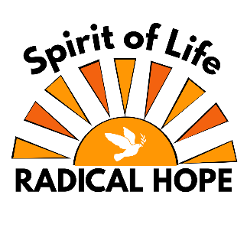
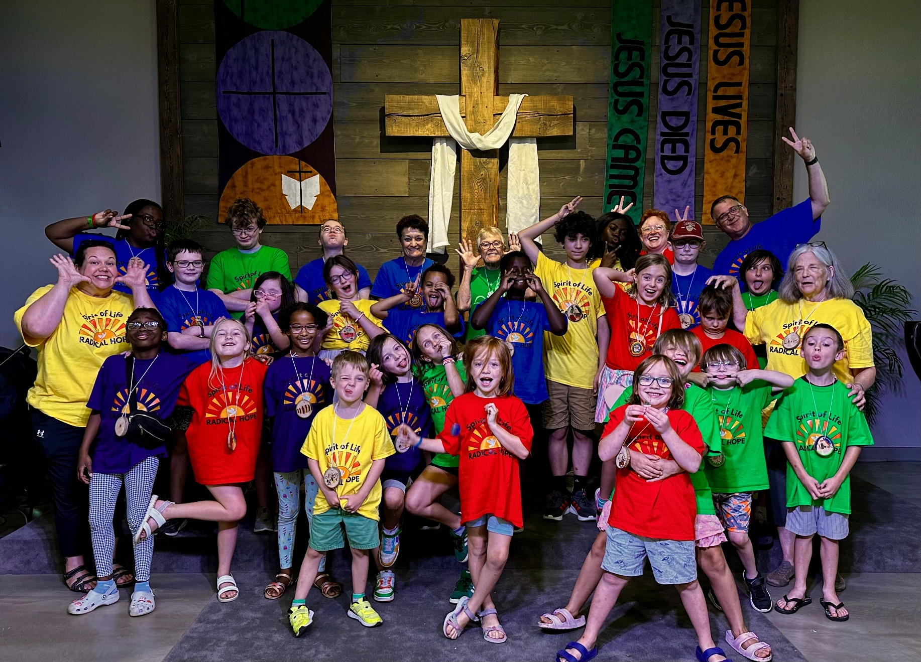

August 17, 2025
CCLI License #3049316 grants permission for reprinting of words and music

CAMP SUNDAY
Thank you for joining us!

We hope you experience the joy of God’s love in our diverse, inclusive, and compassionate community. Come as you are; all are welcome!
Worship is at 10:00 am Sunday mornings in person or may be watched later on YouTube or Facebook.
Restrooms are in the first hallway to the left on exiting the sanctuary.

Order of Worship
August 17, 2025

* All who are able are invited to stand.
Regular attenders, visitors, & members, please complete & return Connect/Prayer cards in offering plate or to the Welcome Table at the back of the sanctuary.

Prelude

Welcome

Greeting

*Opening Song The Greatest Commandment

Day 1 Theme: Hope for a Loving Community

Memory Verse “Love the Lord your God with all your heart, with all your soul, with all your mind, and with all your strength.” Mark 12: 30

Puppet Show

Day 2 Theme: Hope for a Sustainable Community

Memory Verse “In the beginning God created the Heavens and Earth.” Genesis 1:1

*Song Water is Life

Day 3 Theme: Hope for a Just Community

Memory Verse “Whatever you did for one of the least of these brothers and sisters of mine, you did for me.” Mark 25:40

*Song All of Us

Day 4 Theme: Hope for a Peaceful Community

Memory Verse “For we are God’s handiwork, created in Christ Jesus to do good works, which God prepared in advance for us to do.” Ephesians 2:10

Call To Offering

Offering Song Sanctuary

Announcements

Thank you to Volunteers

Day 5 Theme: Hope for a Joyful Community

Memory Verse “Shout with joy to the Lord, all the earth!” Psalm 98:4

*Closing Song We Will Go Out with Joy

Benediction

Postlude

Please join us for coffee and refreshments after worship.

Spirit of Life Presbyterian Church / 14401 Pilot Knob Road / Apple Valley, MN 55124 /
www.spiritoflifeav.org / spirit@spiritoflifeav.org / 952.423.2212

